**Experiment-1:**

**Aim:** Create a simple cloud software application for Flight Reservation System using any Cloud Service Provider to demonstrate SaaS include the necessary fields such as one way, round trip, From, to, Departure, Departure, Travelers & Class, Fare Type, International and Domestic Flights etc

**Step 1:** Select ‘create an application’ and click ‘create from scratch’.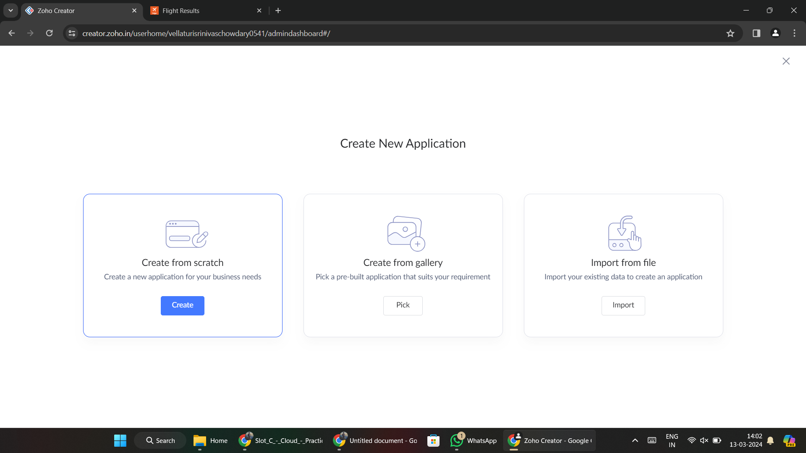

**Step 2:** Name the application and click ‘create application’.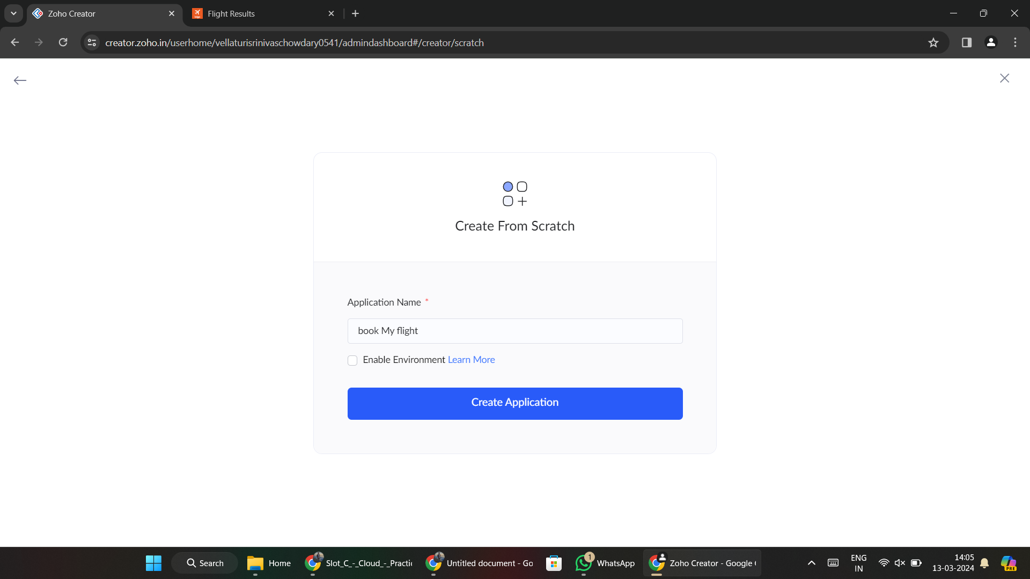

**Step 3:** Click ‘Create New Form’ and select ‘From Scratch’.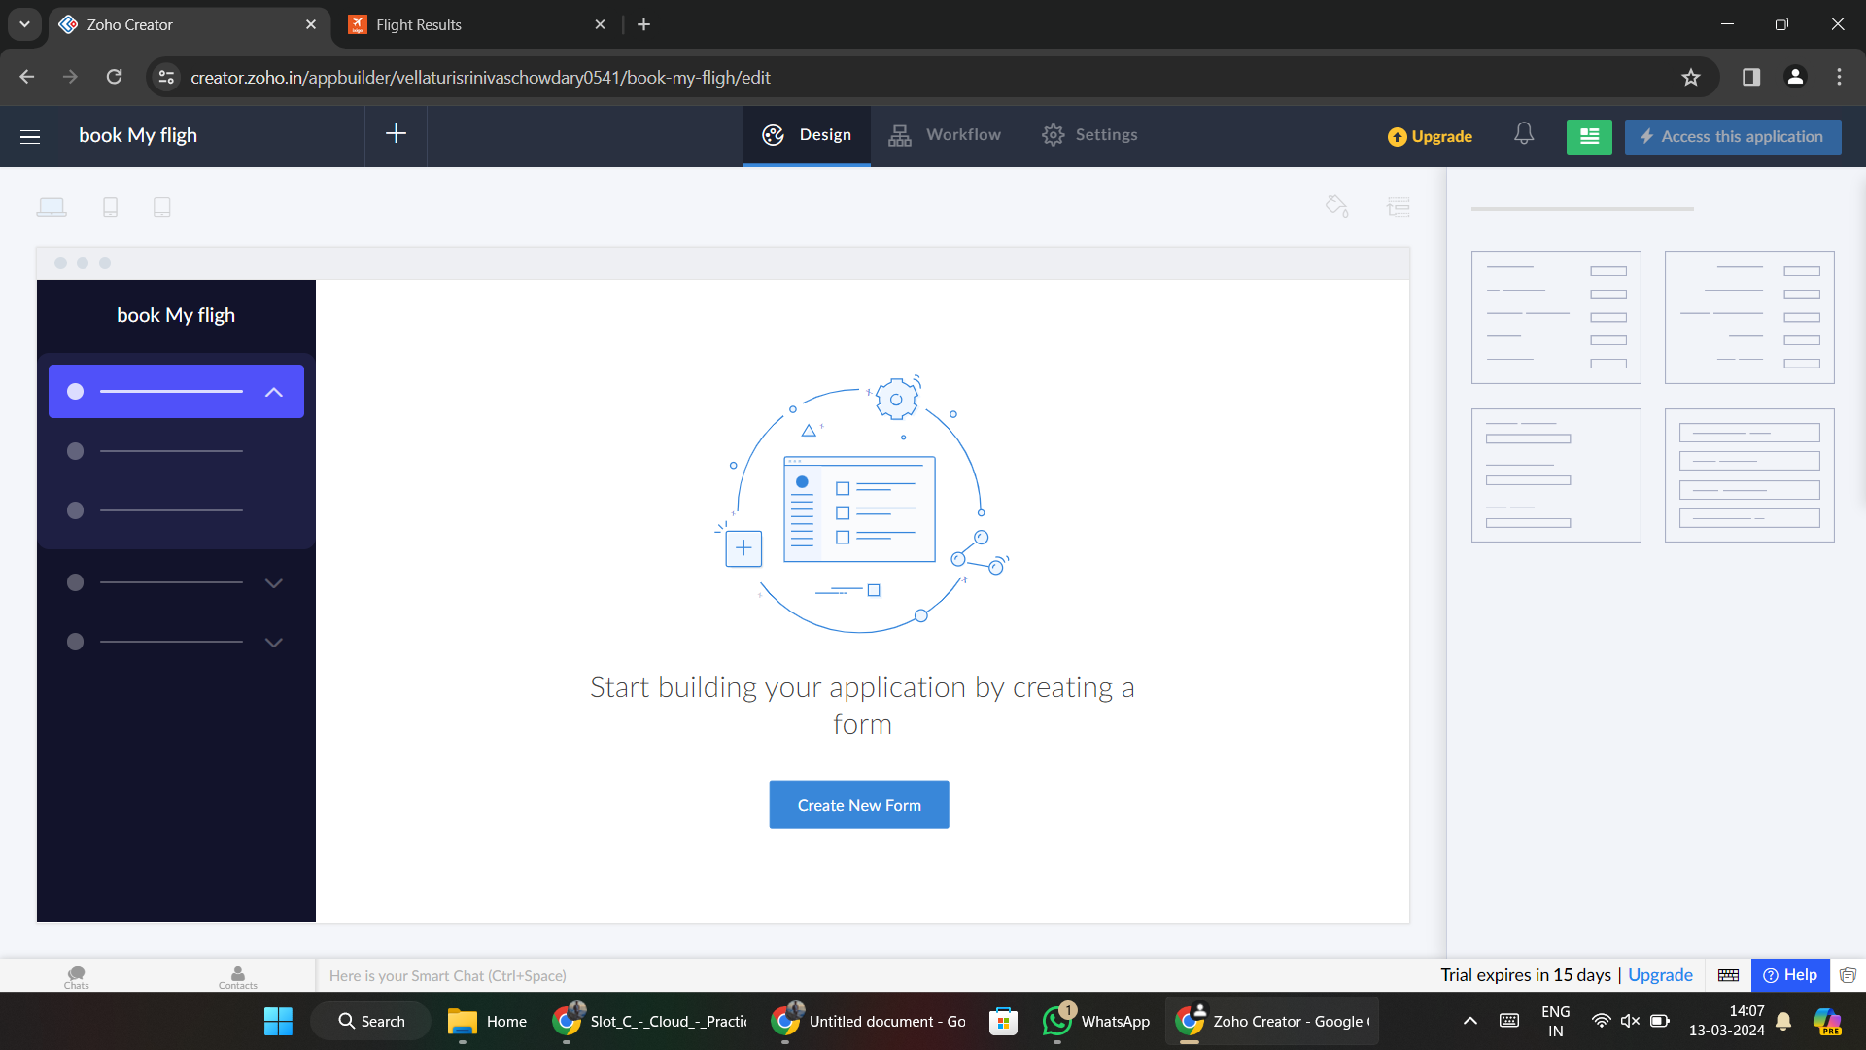

**Step 4:** Name as ‘Booking Details’ and ask some details about booking.

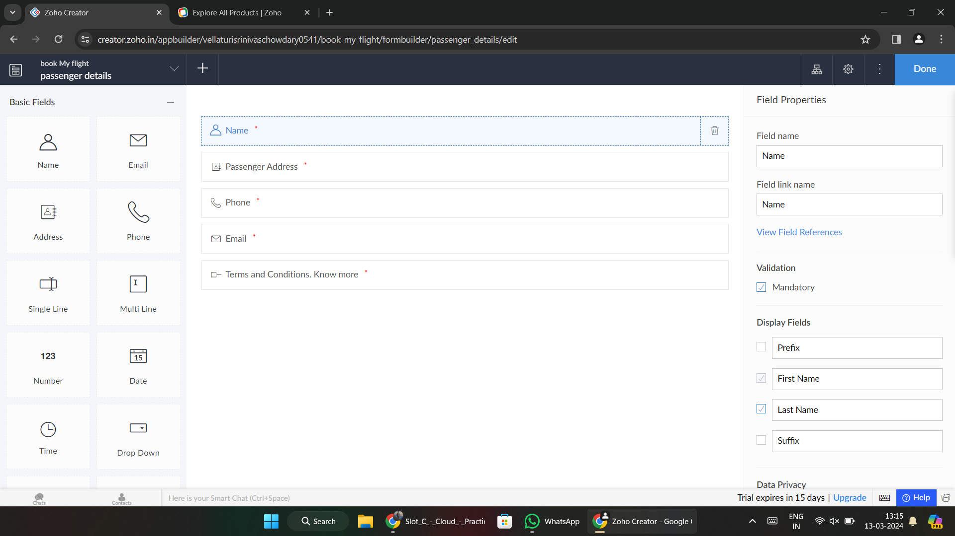

**Step 5:** create some other details(Flight Details, Passenger Details, Payment details)

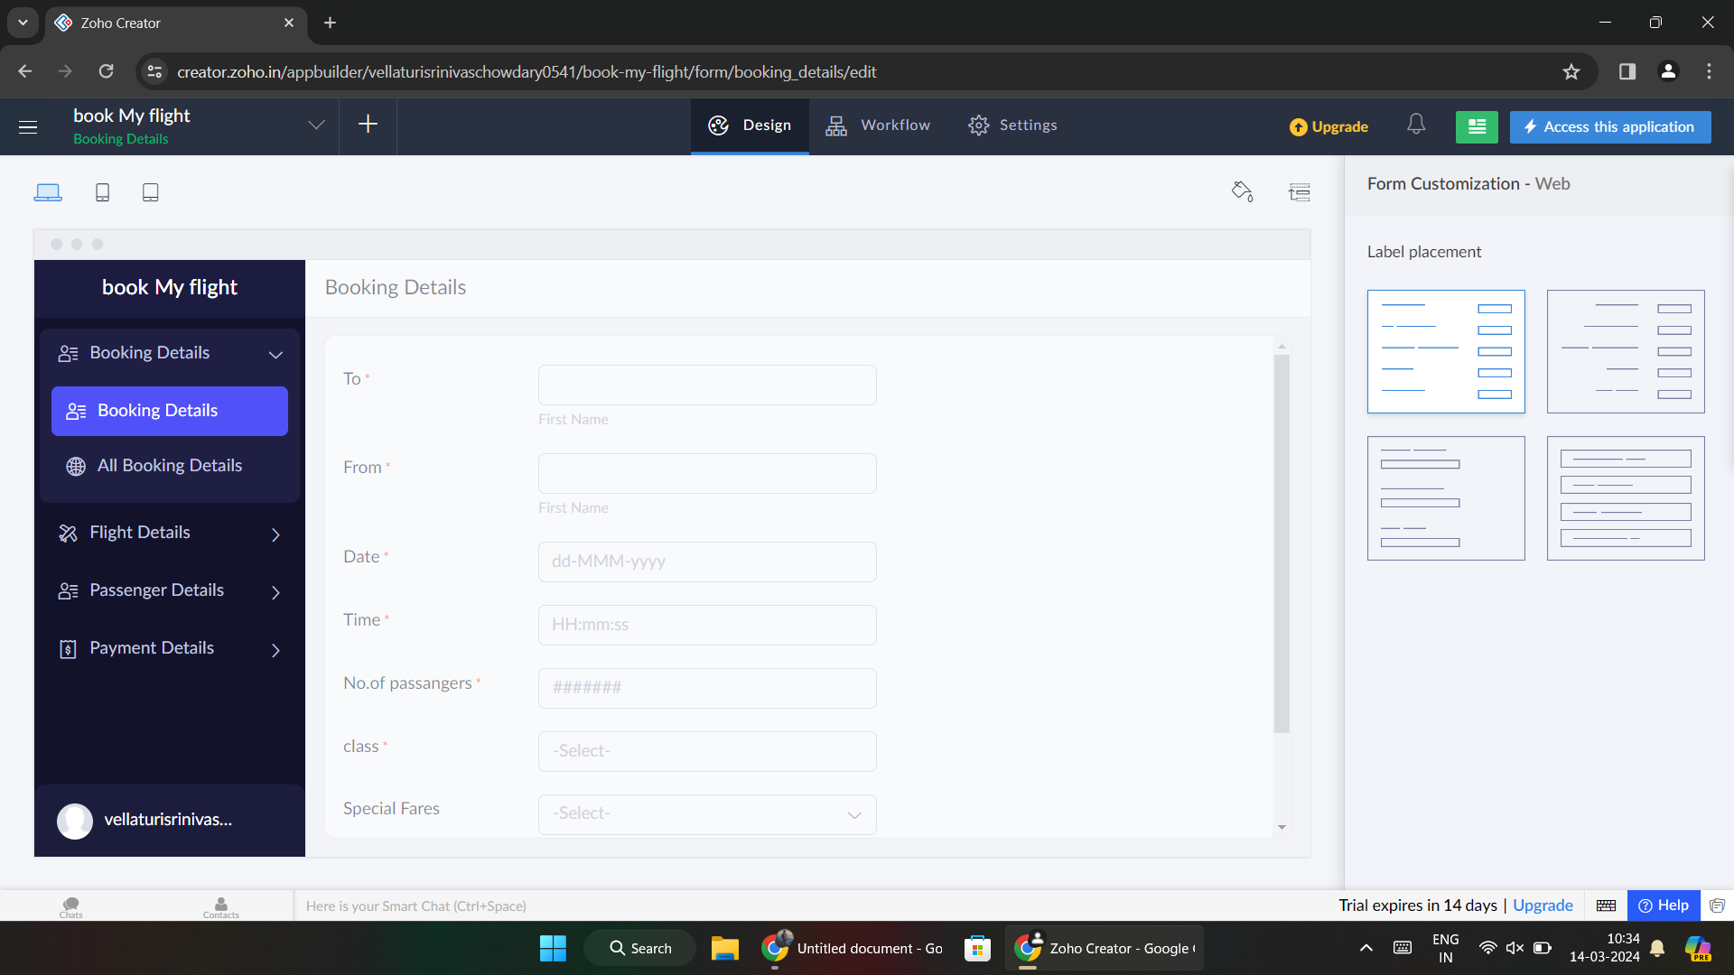

**Step 6:** Click on ‘access this application’ and the application is ready.

